

Strategic Digital Influencing

LSI Modus Operandi

June 2018



Contents

Cycurity’s Strategic Digital Influence (SDI) 3

Large Scale Influencing Modus Operandi 3

Psychology of Influencing 3

Large Scale Influencing Explained 4

LSI Terminology 4

Project Team & Roles 8

LSI Project Design 11

Stage 0 – Operationalize Project Goal 12

Stage 1 – Analyze Issue & Target Audiences 12

Stage 2 – Analyze Discourse & Identify Funnel Pathways 16

Stage 3 – Devise Audience & Messaging Strategy 18

Stage 4 – Initiate Project 19

Stage 5 – Monitoring and KOL Identification 27

Stage 6 – Engaging with Influencers 30

Stage 7 – Measure Influence on Discourse 37

Appendix 38

# Cycurity’s Strategic Digital Influence (SDI)

Cycurity is the hallmark of Strategic Digital Influence (SDI), providing both intelligence and influencing services. Our unique methodologies enable sophisticated human-to-human interactions with very high response and conversion rates on social media.

# Large Scale Influencing Modus Operandi

Cycurity’s Large Scale Influencing utilizes the power of social media to reach millions; helping corporations, governments, and brands tell their narrative, shape opinions and influence decisions.

Due to their nature, LSI projects are both adaptive to changing media trends as well as customizable to client needs and expectations. LSI projects can therefore vary a great deal from one another. The LSI Modus Operandi serves as a basic guideline for the department’s Project Managers, Team Leaders, Community Leaders and Social Media Analysts when setting up a project, trouble-shooting or onboarding. This document outlines the basic modus operandi for Cycurity’s Large Scale Influencing (LSI) projects on Twitter.

# Psychology of Influencing

In order to ensure that our work creates a real and enduring impact on target audiences, Cycurity builds its SDI (Strategic Digital Influence) on the basis of advanced psychological and neuroscience research. Specifically, every project’s messaging is designed based on psychological profiling of the target audience (including its emotional dynamics and its cultural references), as well as corresponding affective and cognitive tactics to ensure that messages are appealing, seamlessly absorbed and remembered. Thus, not only do we raise awareness about a chosen topic; we ensure that attitudes are changed.

In addition, messaging is adapted to dynamic context changes, such as salient news events where the target audience resides, recent political events, and even notable weather.

# Large Scale Influencing Explained

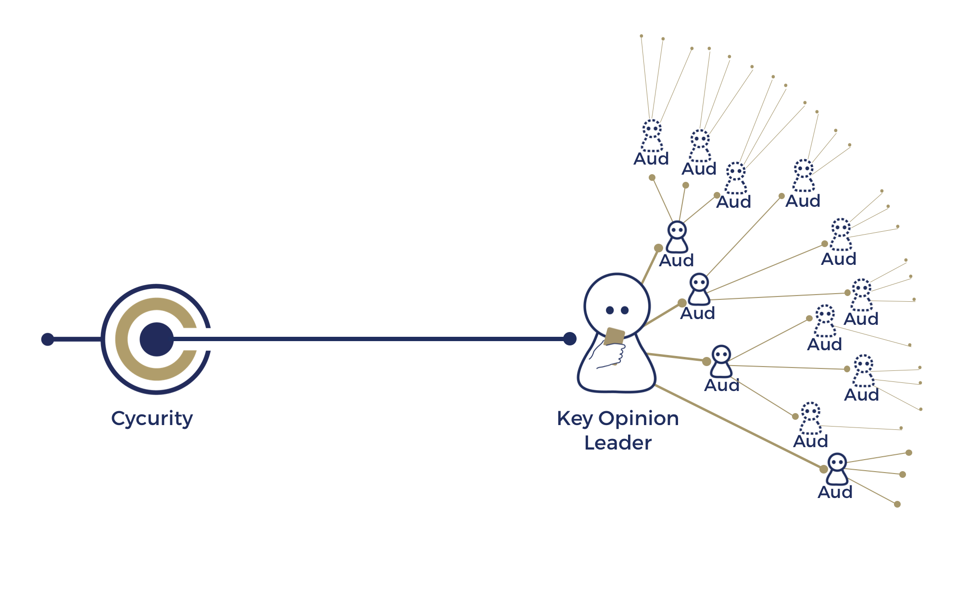

In a nutshell, Large Scale Influencing (LSI) entails one-on-one, human-based relationships with influencers on a massive scale. Cycurity’s LSI services combine human intelligence based methodologies with state of the art technology to ensure that the relationships we build with key opinion leaders are genuine and authentic.

# LSI Terminology

**Influencer** An entity (individual or organization) with attributed influence vis-à-vis a specified audience. While there are differencing industry definitions, “influencer marketing” has traditionally been segmented according to a given number of followers or a given “influence” value (e.g. Klout Score).[1]

**Micro-influencer** A social media account with a following of 1000-10,000 users

**Macro-influencer** A social media account with a following of over 10,000 users

**KOL** (Key Opinion Leader) A social media account identified as being an influencer within a given area of dynamic discourse or “topic” being targeted by an SDI project. To classify as a KOL, an influencer is first categorized as a **Potential KOL** (PKOL) by a project team member or automatically by Cycurity’s “KOL Machine” (KOLM). Only after successfully engaging with a project channel is a potential KOL reclassified as a KOL.[2]

**Static KOL** A KOL identified through research external to CX Social or the KOLM

**Dynamic KOL** A KOL identified through an engagement process in CX Social or by the KOLM

**Potential KOL** A social media account identified as a KOL by the project team and has yet not engaged with a project channel.

**Project Channel** A social media account used on a Cycurity SDI project in order to engage with a targeted audience.

**Mention** A social media post picked up by CX Social according to the project’s query.

**Engagement** A social media account that has responded (taken action) to an action taken by a project channel.

**Action** A post, favorite, retweet, reply posted by a project channel for any reason.

**Account** A social media entity that is not a project channel.

**Opinionated Account** An account that is considered relevant for a project and is not a Potential KOL.

**Irrelevant Account** An account deemed by a project operator as irrelevant for a given project.

**Unicorn** An account labeled by the project manager as of significant or strategic importance to the project.

**CX Social User** (or User) The surrogate name used by Cycurity personnel to connect to CX Social.

**Reputation Content** Actions taken by the project channel in order to build channel reputation.

**Broadcast** A post written by a project channel that can be seen by the channel’s followers.

**Feed** The “Tweets” section of a given Twitter account.

**Responsiveness Level** The tendency of an account to reply and engage with other accounts.

**Influencing Indicators** (I2) Cycurity’s pyramid system used as the Key Performance Indicators (KPI) on LSI Projects:

**Identified** Social Media mention processed by a Cycurity operator (any mention “resolved” by a project operator)

**Contacted** Project-related message sent to an account (any post sent by a project channel to a social media account)

**Engaged** Account responded to project-related message (any account that took an action following a “contacted” post)

**Targeted** KOL received client message (any action taken by a project channel with the intent of promoting the project’s main messages)

**Influenced** Social Media mention processed by operator (any action taken by a KOL as a response to a “targeted” post)

**Mobilized** Any desirable action taken by a KOL or other entity independently promoting a project message due to an interaction with a Cycurity project channel.

**Project Reach** The accumulated, non-unique number of social media accounts exposed to any project content

**Influencing Reach** The accumulated, non-unique number of social media accounts exposed to a project message

Engagement reach = 1

Retweet reach = 1 + number retweeting account’s followers

**Reach** (in social media) A measure of how your content is spread across various social media platforms. You can think of it as the number of unique or non-unique people who see your content.

In a perfect world, every one of your followers will see every piece of content you post. Unfortunately, that’s not the world we live in and not all your fans will see every single post you publish. So reach is a measurement of your effective audience.

**Organic Reach** The number of people who see your posts without you paying to promote them.

**Impressions** The number of times your content is displayed.

An impression means that content was delivered to someone’s feed. A viewer doesn’t have to engage with the post for it to count as an impression. What’s tricky about impressions is that one person can have multiple impressions of the same piece of content.

For example, on Facebook a post can be displayed in the News Feed from the original publisher and appear a second time when a friend shares the publisher’s post. If you saw both forms of activity in your feed, that counts as two impressions for the same post.

**Bridging** The process of taking an “off-topic” mention and leading it “on-topic” through engagements. **– This is Cycurity’s key unique capability.**

**Audience Profiling** Researching a target audience in order to understand any idiosyncrasies in its behavior, its emotional predispositions, its cultural references and any other distinctive features. This is done in order to tailor message strategy and format for maximum effect.

# Project Team & Roles

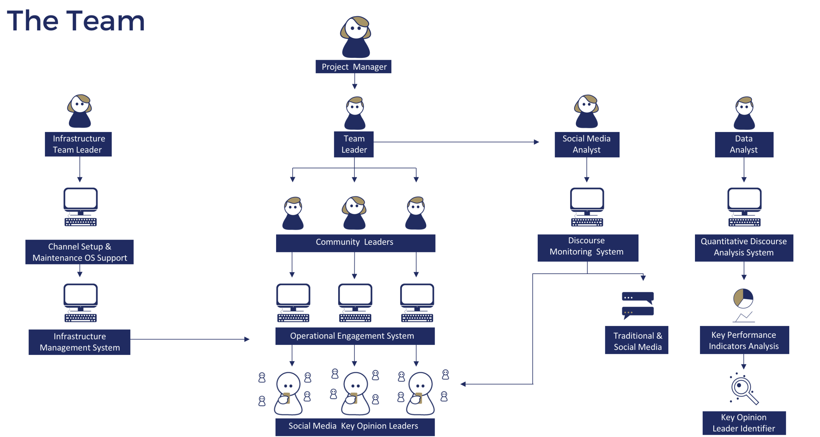

Functions and roles within teams

Project Manager:

The project manager has overall responsibility for project strategy and adapting Cycurity methodologies to suit the bespoke needs of each project. The project manager’s responsibilities include:

* Client's POC and is in charge of client management and communications.
* Manages project team and Team Leader.
* Will be in direct contact with upper management (Department Manager, COO, CEO, Office Admin).
* May manage between one and three projects simultaneously.
* Bears full responsibility in delivering client’s desired results.
* The position entails:
  + Formulation of end-goal and identification of values to client
  + Recruitment and on-boarding of team members
  + Overseeing the research and BI gathering stage by the SMA
  + Overseeing the infrastructure stage lead by the TL
  + Formulation of project strategy and defense in front of Red Team
  + Approval of reports to clients
  + Hosting weekly team meeting
  + Approval of query & KWD changes
  + Constant QA

Team Leader:

* Responsible for the implementation of the project strategy.
* The team’s operational manager.
* The position entails:
  + Directly managing daily operation of the Community Leaders and the SM Analyst
  + Team member training and mentoring
  + QA of teamwork in light of strategy and SMA reports
  + Internal and external reporting
  + Query setup and KWDs recommendations
  + Monitoring dashboards (KPIs/ alerts/ performance)

* TL may be a CL

Community Leader:

* Responsible for managing a community surrounding a core topic identified by the project strategy.
* The Operator’s operational manager and will report directly to the TL.
* The position entails:
  + Management of project channels within the core topic (1X10 actions/day)
  + Formulation of posts and campaigns
  + Answering suggestions
  + Identifying KOLs based on identification system
  + Tagging KOLs and mentions according to KPIs/ RSI
  + Writing weekly/biweekly summary of efforts for the report
  + Suggestion of KWDs changes when necessary
  + Monitoring relevant dashboards (KPIs/ alerts/ performance)

SMA

* Responsible for monitoring media relevant to the project’s interests.
* Report directly to the TL.
* Multiple projects may share a single SMA
* The position entails:
  + Setting up and following media monitors (Crimson Hexagon/ CS-Social/ TweetDeck/ etc.)
  + Evaluating compliance to project strategy
  + Suggesting message lines and tweaking of campaign topics/KWDs based on media chatter
  + Defining KOLs and identification system requirements
  + Contribution to weekly/biweekly summary of efforts for report
  + Monitoring relevant dashboards

LSI Project Design

**Stage 0 –** Operationalize

Client Goal



**Stage 1 –** Analyze Issue & Target Audiences



**Stage 7 –** Measure Influence on Discourse



**Stage 5 –** Monitoring

& KOL Identification



**Stage 6 –** Engage Influencers



**Stage 4 –** Initiate Project

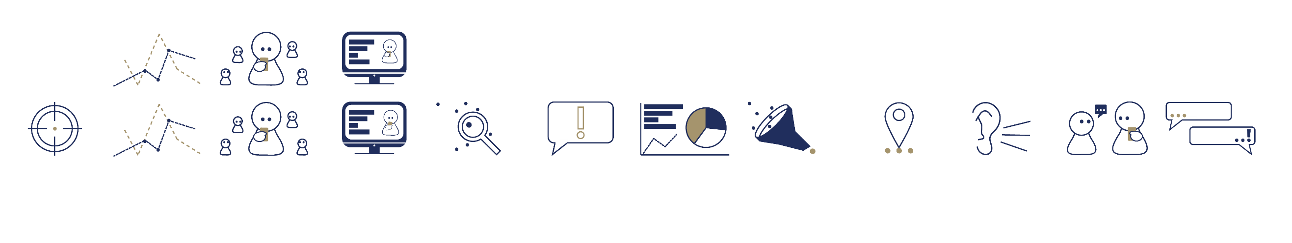

**Stage 3 –** Devise Audience

& Messaging Strategy



**Stage 2 –** Analyze Discourse & Identify Funnel Pathways



**Stage 0 –** Operationalize Project Goal

Communication with End-Client

Execution: Project Manager & Project Owner

* Extract client’s true definition/vision of success/victory as opposed to perceived, objective goal.
  + Example: “Create awareness to the benefits of drinking water in the United States” translates into “Increase the amount of positive twitter mentions of fresh water drinking made by millennials in the state of New York by 10% over the course of 1 year.”
* Discuss/ understand client expectations regarding reliability of measurement.
  + While Cycurity operated based on measurable KPIs, projects do not occur within a vacuum and result assessment may vary based on variation of keywords and measuring tools.
* Translate expected outcome into operational targets, devise Memorandum of Understanding document & circle back with client.

**Product 0 – MOU**:

Target results

Agreed upon KPIs (measurements)

Milestones

Deliverables

Legal disclaimers



**Stage 1 –** Analyze Issue & Target Audiences

Open Source Issue Research

Execution: researcher based on brief from project manager & MOU

* Conduct in-depth open source research of the issue using a Crimson Hexagon monitor/ Google Scholar / magazines / Vlogs / Lectures / TED talks / online courses (Coursera & Lynda)/ news sources / blogs etc. to provide insights on the following points:
  1. Historical Aspects – is the issue under dispute? If so, what is the history of the dispute/ what are the underlying issues? What are the main existing narratives?

*Focus research on the right location for this project.

* 1. Objective Stakes – what are the economic, political and commercial stakes of the issue? Who gains/ who loses?
  2. Underlying normative stakes – What are the historical meaning, historicism, morality and political values involved in this issue? Does this connect to competing perceptions of what should be?
  3. Underlying social stakes – Has this issue become a political divider or banner issue? is it a prominent social, political or demographic divider? Group identity marker?
     + - Example: Us/them – global warming attitudes are not about the underlying issues as much as a partisan flag.
  4. Psychological stakes/Underlying emotional stakes (personal emotional attachment) – How emotionally charged is the issue and why? Has it taken on a personal significance for people involved that goes beyond the political or economic?
  5. Elites and thought leaders – Are attitudes on this issue heavily elite driven? Is this a topic in which most people’s opinions are driven by experts and elites?

**Product 1ai – Written report**

Brief report with 6 sections and a simple summary at the beginning

Social Media Issue Research

Execution: Social Media Analyst based on brief from project manager

* Conduct social media listening research of the issue via Crimson Hexagon (buzz and opinion monitors) to provide insights on the following points:

1. Related topics and subtopics – What are the main topics involved with this issue? What are the most frequently used words and terms? Create an opinion monitor based on categories relevant to the project.
2. Opinion analysis – Are people opinionated about this topic? What are the main opinions/ arguments/ positions being expressed? Are people taking positions and making judgement?
3. Emotional analysis – what are the emotions being expressed in relation to this topic and related sub-topics? Are they positive or negative? Can they be refined into specific emotions (disgust, anger, fear, joy)? *Reference Crimson sentiment analysis/ train opinion monitor.
4. Peak analysis – Where and why has this topic peaked? Did the opinions and emotions change over time?
5. Demographic breakdown – Is this topic more popular among certain demographic groups (age, gender, race if possible) than others?
6. Geographic – Is there a notable differentiation regarding the topic based on the location or declared location of the Tweeters?

**Product 1aii – Written report**

Brief report divided into 5 sections, with simple summary at the beginning

**Product 1aiii** **– Audience definition brief**

Target audience initial identification and segmentation – short brief produced by Knowledge Center and Project Manager based on products 1ai & 1aii and the client’s desired end target audience (MOU). Provide 1-2 lines of explanation on each audience and why it is being targeted.

Audience Research (OSINT)

Execution: researcher based on product 1aiii & brief from Project Manager

* End - target audience profiling – what are its emotional needs and dynamics? Use Google Scholar and OSINT sources, looking for in news articles, magazine reports, statistical reports, videos or poll data, and journal articles re the following:

1. Emotional predispositions – are there any emotional dynamics that mark this audience, e.g., narcissism or anxiety in millennials
2. Cultural references – What are the main LIVE/recent cultural (TV, written, movies) for this audience? (e.g., Game of Thrones? Memes? Fidget Spinners?)
3. Political trends & preferences – Can we find out if this audience has any marked political leanings? Specific attitudes? (e.g., rural working-class men are very tough on immigration)
4. Demographics & influence thereof – If a target audience is not defined demographically (if for example, we target liberals in Los Angeles), is there a distinct demographic makeup to this audience?
5. Social media – Does this audience use social media? If so which platforms? How do they use it? Look for market research reports.

**Product 1bi** - Report divided into 5 sections as per a.-e., 2-10 pages.

Audience Research (SMA)

Execution: SMA based on product 1aiii & brief from Project

* NOTE: There is currently no easy or fully reliable way to segment audiences demographically and then do research on them. So, we will proceed by a mixed approach, searching and whittling down, as possible.   
    
  On Crimson:

1. Filter to the extent possible on demographic basis or basis suggested in **1aiii**
2. Run a broad positive/negative affinity query: “I love, I really like, I would die for, …is life, and crazy about, adore…”// “I hate, I detest, I loathe, it sucks when, is disgusting, …” etc. TO BE DEFINED AND REFINED.
3. Look at topic wheel for results, identify 2-3 main topics that go along with positive/negative declarations, using judgment to weed out colloquialisms and irrelevancies
4. Look at age/gender/location breakdown to draw insights re targeted audience. Does targeted segment behave the same as other age or gender segments? Etc.
5. RUN QUERIES on 2-3 3 main subtopics in (c); then repeat (c) and (d).
6. Come up with insights regarding this audience’s tastes and preferences and emotional predispositions.

**Product 1bii –** Report, summarizing the above, with ½ page bullet point takeaways at start.  
 **Product 1biii** – Knowledge Center uses reports 1aiii, 1bi, 1bii to define3-4 approx. user-defined KOL (along issue, psychological and social lines) categories for psych machine and strategy  
  
KC with PM also devise EMOTIONAL strategy basics, including emotions to target for each KOL category.

**Stage 2 –** Analyze Discourse & Identify Funnel Pathways

Key Project Message –

For every target audience identified in Stage 1, above, the Project Manager and Knowledge Center develop a preliminary strategy along with preliminary key message(s), on the basis of the MOU and the findings from stage 1 re Audiences and Issue. Then, QDA to define a message funnel is performed for each of these messages. This will serve to determine the cognitive tactics used to reach key messages, once engaged with KOL.

**Product 2a-** preliminary strategy and preliminary key messages by KOL categories.

Quantitative – Qualitative Discourse Analysis –

Execution: Project Manager and SMA

**Traditional QDA**

Find relevant posts portray project message on SNS

Identify key words and key terms indicative to discourse

Statistically analyze posts based on keyword frequencies

Run listening monitor based on identified key terms

Group results into topics and queries for engagement platform



1. For each KOL category, create a Crimson Hexagon buzz monitor with basic keywords and key-terms attributed to the KOL preliminary key message (from product 2a).
2. Analyze result looking 1 year back and identify at least 20 social media posts in which representatives of that KOL category support the preliminary key message.
3. Analyze above posts to identify keywords and key-terms that represent the manner in which that KOL category naturally mentions the preliminary key message.
4. Create a Crimson Hexagon buzz monitor with the keywords and terms identified in stage 2. Looking 1 year back, export to excel (approx. 150K-200K posts).
5. SMA statistically analyzes posts in the newly formed excel file in order to identify most frequently used words and terms.
6. SMA and project manager ideate in order to group above results into topics relevant for the project’s main target audiences (as were determined in product 1bi & 1bii.

**Crimson Based QDA**

1. For each KOL category, create a Crimson Hexagon opinion monitor with basic keywords and key-terms attributed to the KOL preliminary key message (from product 2a).
2. Analyze results looking back 1 year, create following categories and train each via at least 50 social media posts.
   1. Ideal – posts that closely resemble or match the preliminary key message
   2. Close – posts that are in the direction of the key message but lacking in scope and sentiment
   3. Relevant – posts that are on topic without being hostile
   4. Hostile – post that are on topic but clash strongly with the key message
   5. Irrelevant – posts that contain the keywords but are irrelevant to the topic
3. Broaden query of above monitor to include only topic related keywords and key terms. Run monitor.
4. Look at results to evaluate whether categories a-e are accurately populated. If yes, go to step 5. If not, continue training with more posts.
5. For categories b&c identify most prevalent keywords & terms.
6. Check the peaks to determine if any key influential events should be referred to in the final query.
7. For each KOL category, build final project topic query on the basis of points 5 & 6.
   1. Note: in operation phase, inbox should only include posts from categories b&c.

**Stage 3 –** Devise Audience & Messaging Strategy

Discourse Funnel

QDA identified the project’s dominant 2nd and 3rd tier topics. These topics may naturally lead members of the project’s target audience to accept the project’s message.

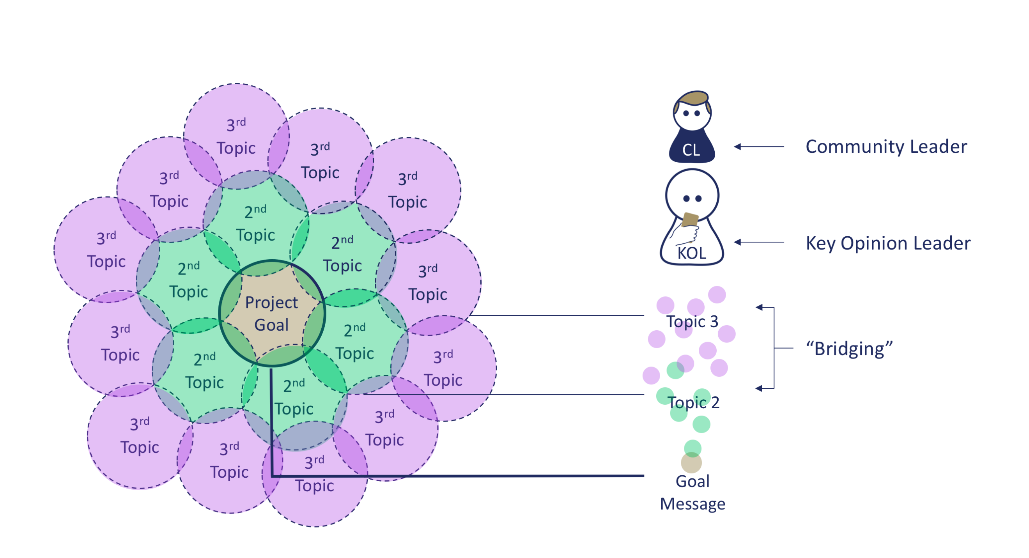

In light of the outcome of the QDA process and in respect to the MOU and product of stage 1 the project manager, aided by the Knowledge Center, devises the project’s messaging strategies.

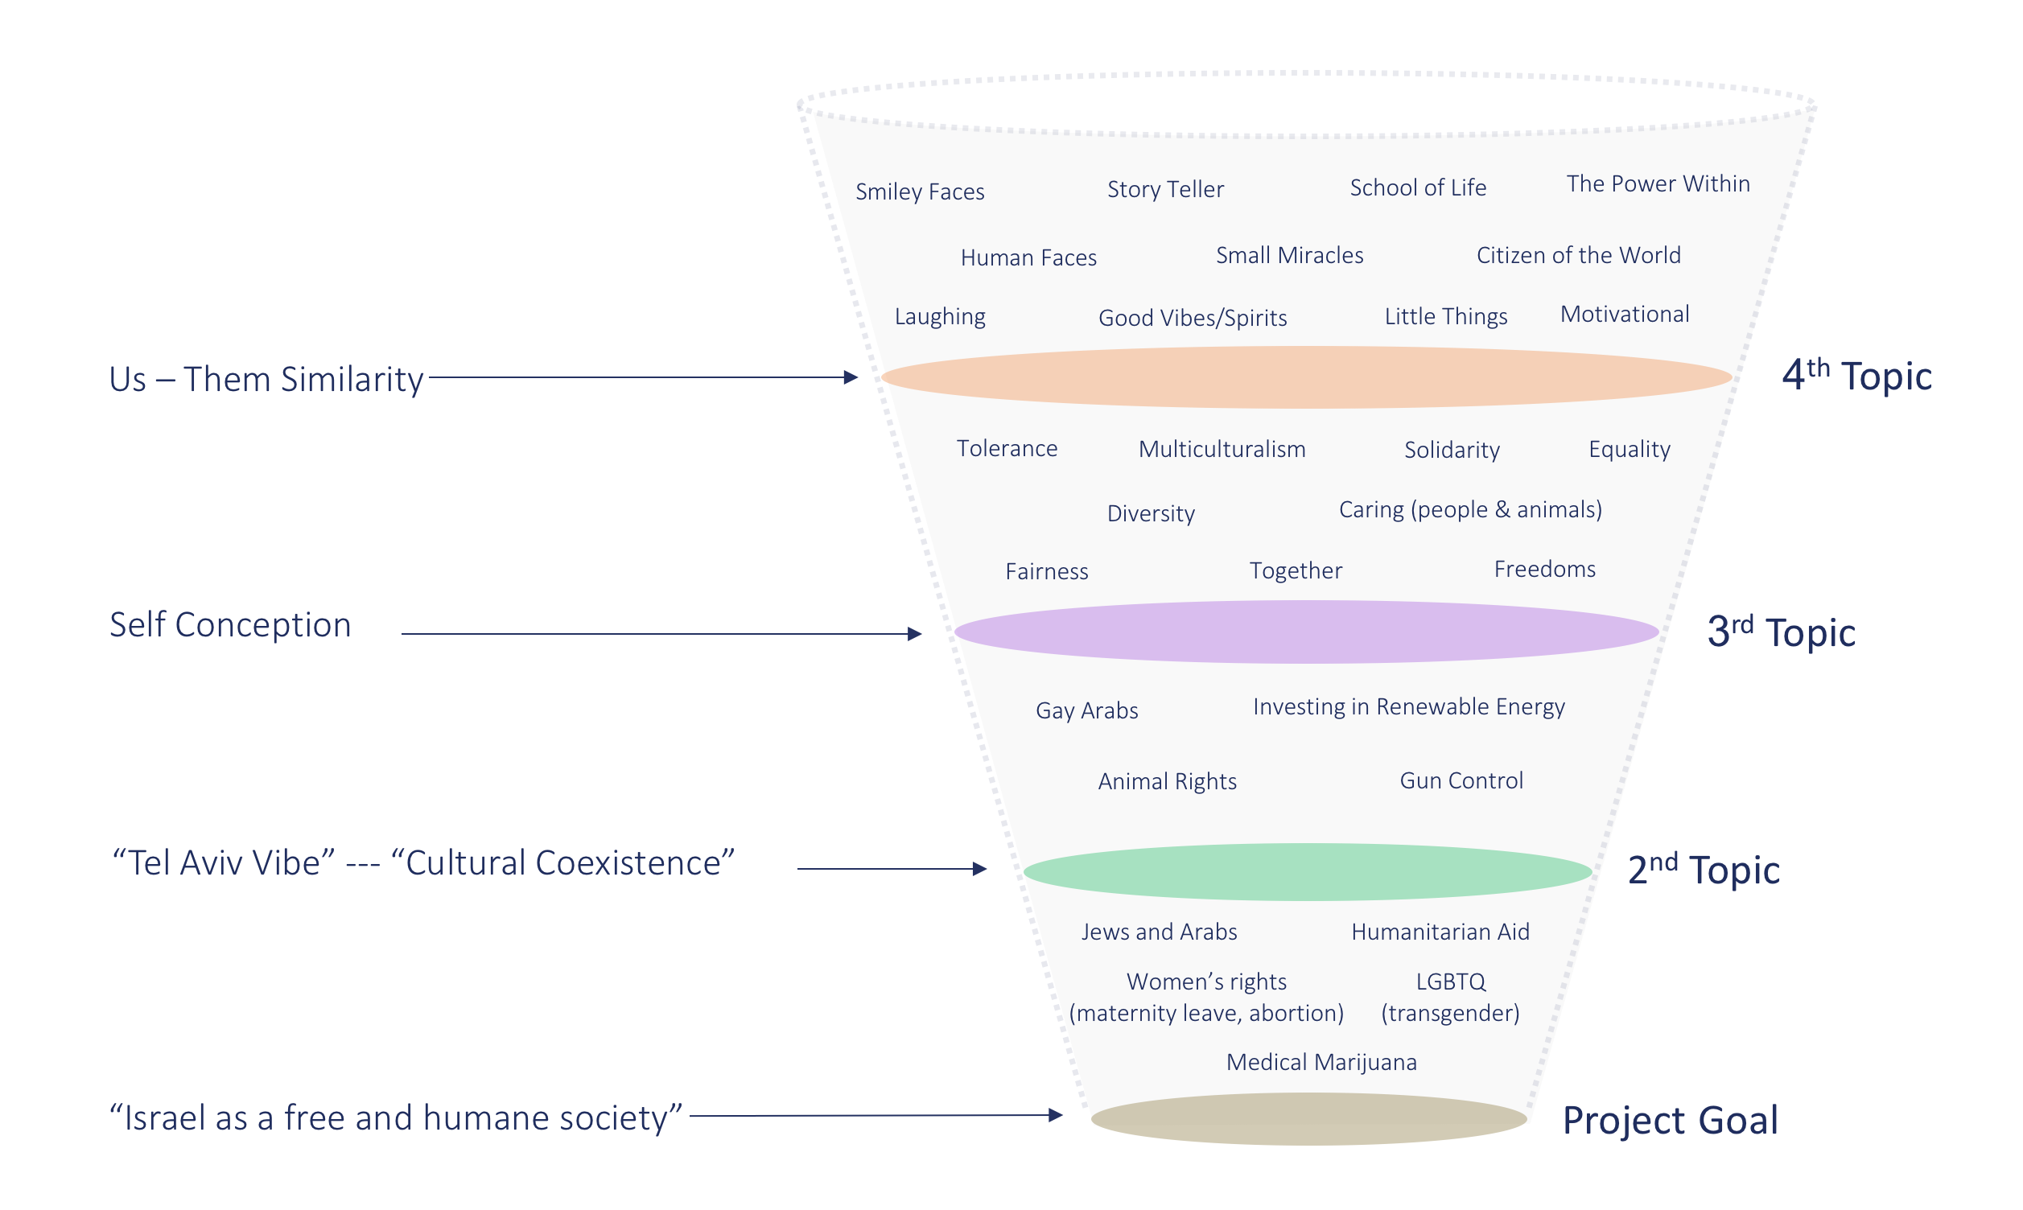

Project messaging strategies are the theoretical roadmap or funnel in which discussions from 2nd and 3rd tier topics can be swayed or directed to raising the project’s key message in the most authentic and natural manner.

Messaging strategies identify the chosen project communities and delivers specific instructions for the project team to create the project’s social media channels.

Red Team

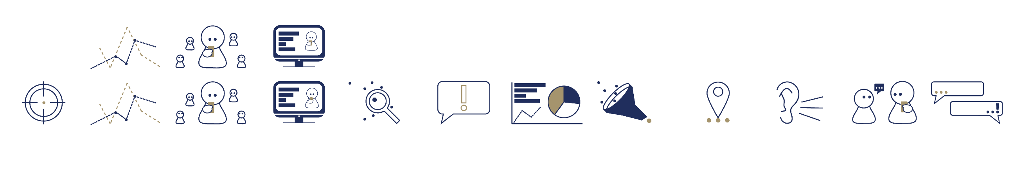Project managers present products of project plan to an internal red-team that is comprised of higher management, the Knowledge Center. LSI department head and selected project managers and team leaders.

**Stage 4 –** Initiate Project

Infrastructure Team Project Initiation Procedure

**CX-Social Account – a standalone environment for every project.**

**The standalone account is what separates every project from one another.

Purchase of account, users and streams is done by Oren – after deciding on the amount of SM channels and team members.

**Users – giving access to CX-Social**

**Every project has its own individual users while the project is active\operational.

CS-Social users are created with a generic Gmail account.

The users have generic names so in case of need they can be shifted from one team member\project to another, with no association to any particular person in the company.

* Newly created users have only permissions to view CS-Social – No permissions to operate anything at this stage.
* **Usually we will give permission to one user to view and use the account – this will eventually be used by the PM\SMA to start setting up queries etc.**
* Every CS-Social account comes with 1 Administrator user – this is a superuser, he is the only one with permissions to set up the account and the only one who has access to the entire account.
* A file with log-in credentials is sent to the project manager once the users are connected.

**Project\Topic set up –**

**Topics can be set up only after the project manager has finalized the relevant topics for his project.

* The topics are set up manually.
* The social profiles and keyword search can only be connected to topics.
* Each topic is an inbox.
* After setting up the topics – this is ready for the PM\SMA to start testing and setting up queries\keyword searches for those topics.
* **We do no connect social profiles right upon topic set up.**

**Social profiles –**

**every project has its own social profiles

Social profiles are connected to topics, and can be connected only when topics are set up.

Social profiles are connected gradually, only when their identities are adjusted accordingly (handle\name\bio etc.).

* We coordinate the dates of connecting the social profiles with the project manager, based on the readiness of the team to engage using those account.
* If there is no team yet – we will not connect the social profiles.
* The social profiles are connected to topics based on the PM's decision.

**Custom User roles\Permissions –**

**Other than giving permission to one user to use the account upon initial set up - **creating custom user roles is the final step.**

**CS-Social provides us with built-in user-roles, but we create custom ones – this allows us to be very flexible and specific with our permission.

* Custom user roles define the type of actions a user with this user-role is allowed to perform, and what topics\inbox he can see, what social profiles he can use etc.
* User-roles set up is based on the PM's decision – what operator uses what topic\social profile etc.
* This also defines levels of permission to the system – Project manager, Team leader, Community leader, Viewer etc.

**assigning permission to user roles-

* Every user can have only 1 user role assigned to it.
* Every user role can be assigned to more than 1 user.

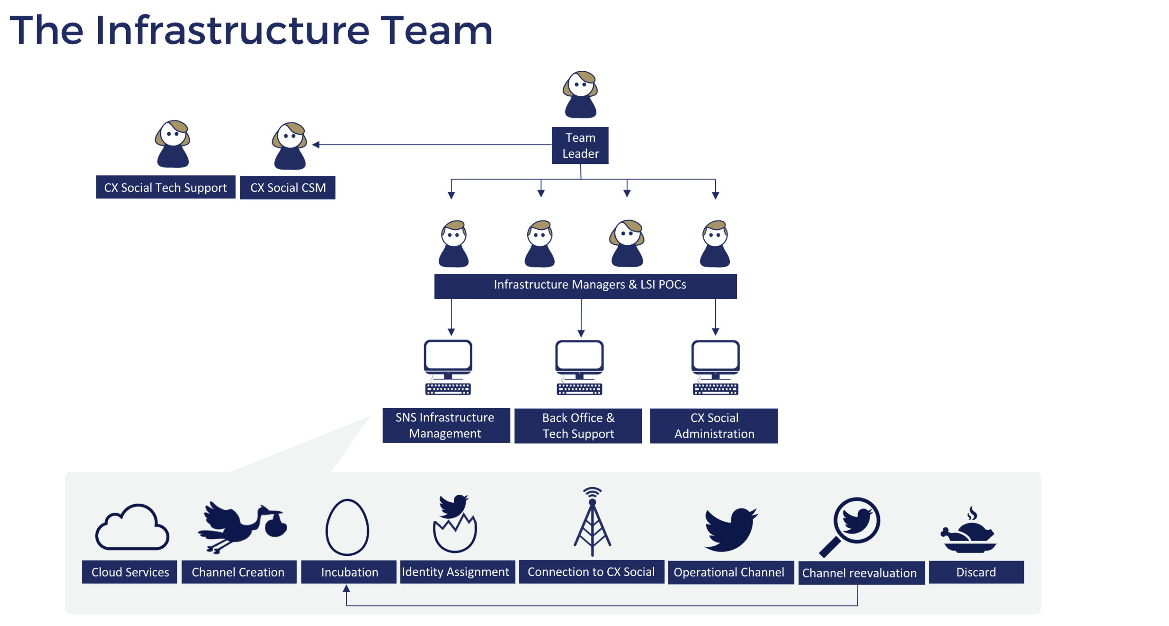

SMA Project Initiation –

Social Listening on Crimson Hexagon

**Setup – Buzz Monitor**

1. The buzz monitor and the opinion monitor are both tools through which we perform (social) media discourse analysis.
2. After carefully examining OSINT research results and client’s brief, the SMA will start constructing a keyword search, which should produce relevant (social) media mentions.
3. The keyword search is built with Boolean semantics; this allows the SMA to make the search as wide or as narrow as possible in order to meet requirements.
4. In the setup stage of the buzz monitor it needs to be decided which media platforms the monitor needs to cover, the search may include (social) networks such as: Facebook, Twitter, Instagram, YouTube, Tumblr but it can also contain platforms such as: Blogs, Forums and Reviews.
5. During the setup date ranges also need to be specified; Crimson can produce data going back as far as May 2008 up until the day before the setup date.
6. The monitor can be limited to specific languages, the system covers 40 languages from which 13 are supported and 27 are unsupported, meaning that it will always produce results when querying in any of these 40 languages but the results within an unsupported language search will be less reliable. Supported languages include: English, Japanese, Spanish, Italian, Arabic, Chinese, Portuguese, French, German, Russian, Turkish, Dutch, Korean.
7. The keyword search can be limited to predefined geolocations, this can be done on both national (cities) and international (countries) level. Once the monitor has been set up it will be possible to drill down into the produced data via location.
8. It is also possible to query Crimson’s database through gender, age and author interests. These settings however are less reliable because the system needs to rely on its own capability to make estimations. These conditions need to be handled with care.
9. Whitelists and Blacklists can be plugged into the search, these respectively target or filter out specific social media users/accounts for monitoring purposes.

**Analysis – Buzz Monitor**

1. Crimson provides a large variety of datasets and visualizations within the monitor ready for analysis
2. A buzz monitor does provide insights on overall sentiment and emotions from within the extracted data but it needs to be noted that Crimson relies here strongly on its own language processing capabilities and internal database. This means that results will not always be as reliable.
3. The volume of mentions will be displayed including the actual post lists. This makes it possible to analyze discourse peaks.
4. ForSight does provide an overview of the most popular/shared URL’s and the top hosts for the URL’s.
5. When monitoring Twitter, Crimson does provide a Twitter Dashboard; here the most popular/shared hashtags are being presented as well as the most mentioned twitter handles and most Retweeted posts.
6. The division of content source penetration is visualized within the monitor.
7. The monitor contains: Topic Wheels, Clusters, Word Clouds, Affinity Bulbs and Trend Waves, which respectively present the main topics within the discourse, the main associations between used words, the most used words, the affinities of authors against the whole of Twitters and the main trends associated with the queried keywords.
8. Forsight visualizes division of demographics and distribution of mentions by geolocation – this data is presented on a world map and a drill down into the actual post list of the particular location is available.
9. The most notable authors are presented in two separate ways: Authorities are the social media users which are considered to have the most influence within the analyzed discourse, this is based on their Klout score (a third party social media influence scoring system. The most Prolific authors are the social media users which most often use the queried keywords and therefore by default they are the ones that are considered to initiate conversations regarding the analyzed topic mostly.

**Setup – Opinion Monitor**

1. The setup of an Opinion Monitor show strong resemblance with the setup of a Buzz Monitor. There is however one crucial difference.
2. The Opinion Monitor contains an additional application aside from all the functionalities, a Buzz Monitor possesses.
3. The above application is called BrightView; this is the machine learning capability of the system.
4. This module makes it possible to train the system conform project requirements.
5. The monitor can be segmented in any desired way; these segmentations or opinions can be sentiments but this is not a necessity.
6. With a thorough training the SMA is capable of conditionalizing the platform by the aforementioned segmentations.
7. Once BrightView is properly trained the algorithm will start identifying patterns and group the so-called opinions
8. The system will visualize the segmentation with bar graphs, with a different color for each segment. It will also provide the percentages including the change rates over time.

**Analysis – Opinion Monitor**

1. Once the training is completed an analysis of the different opinions can be made.
2. The above-mentioned graphs can be used to understand peaks and change rates over time.
3. The graphs can be displayed by day, week, or month. The graphs can be displayed in bar, line or area graphs.
4. All data in the graphs is clickable and by doing so different dashboards will be opened.
5. It is possible to observe topic wheels, clusters, word clouds and post lists for each separate dataset within the graphs.

**CX Social – Query Building**

1. The query building process in CX Social takes place in the desired project environment.
2. Within this environment the SMA needs to identify the desired topic stream.
3. After reaching the topic stream the option to create or edit a keyword search becomes available.
4. The SMA then needs to upload the new query into CX Social. This is done inside the Query Builder.
5. It is advised to use the advanced setup within the query setup screen because here the SMA is able to paste the Crimson query directly into the system.
6. It is important to keep in mind that, although closely related, the Boolean Semantics in Crimson and CX Social are not completely similar.
7. Some operators which do exist in Crimson do not exist in Engagor and vice versa. E.g. the Asterisks operator does not work in Engagor
8. In Engagor it is required to perform a large part of the set-up configuration within the query building process. This means that in Engagor the query itself needs to include conditions such as: Location, Language and Source Domain.
9. A query in Engagor cannot be as Complex as in Crimson. The reason for this limitation is the fact that there is a maximum amount of combinations the system can handle.
10. Each Query in Engagor can handle up to 80 word combinations. Any Query that could potentially produce more than 80 combinations will not be validated.
11. In this case queries either need to be shortened/tweaked or broken down and divided over different streams.

**CX Social - Inbox Configuration**

1. The Inbox needs to be configured in such a manner that it will only consist of mentions that meet predefined conditions, e.g: no replies or retweets should enter the Inbox. Mentions with specific tags should not enter the inbox. Tweets from particular users are not allowed to enter the inbox. Or only the mentions of users with a minimum or maximum number of followers are allowed to enter the inbox.

CX Social Project Setup (Julian)

**Dashboards & Smart Folders**

CX Social POC will set up the initial dashboards and smart folders together with the project’s Team Leader to eventually hand-over this task.

**Standard Dashboards**

* + 1. Standard Dashboard per CL
       1. Actions per Twitter/ project channel (Replies, Retweets, Broadcasts)
       2. Untagged Replies
       3. Top Hashtags/ Trends
    2. Standard Dashboard for PM/TL
       1. Chart of Influencing Indicators per each CL (via CX Social User)
       2. Table of daily Actions per CL
       3. Outbox (Replies or all actions) per CL
    3. Report dashboard (total numbers/whole project)
       1. Cumulative Reach (chart)
       2. Mentions Resolved (handled/ single number widget)
       3. Total mentions count (all mentions that came into inboxes/ single number widget)
       4. Influencing Indicators (chart and table)
       5. Number of KOLs and PKOLs (single number widget)
    4. Internal reporting dashboards (send automatically on a weekly basis)
       1. Management Report
       2. Actions (total) last week and last month
       3. Influencing Indicators (total) last week and last month
       4. Reach last week and last moth
       5. Project Manager Report
          1. Actions (per CL/ CS-Social User) last week and last month
          2. Influecing Indicators (per CL/ CS-Social User) last week and last month
          3. Original/ Own posts retweeted last week and last month
          4. Reach (total) last week and last month

**Standard Smartfolders (per Topic)**

* + 1. KOLs/ PKOLs
    2. Replies
    3. Retweets

**Stage 5 –** Monitoring and KOL Identification

**Monitoring**

It is incumbent upon every project to incorporate a comprehensive mechanism for monitoring events and trends that may be relevant to the project in real time. The standardized in-house tool is known as the Project Intelligence Monitor (PIM).[3]

**Key Opinion Leader Identification Theory**

**The need for a definition:**

The need for a precise definition of key opinion leaders is twofold. First, the methodological need. As KOLs are central for LSI campaigns, it is necessary to find a more precise definition.

Second, the operational need. Large scale influencing can be more efficiently done with a clear definition of KOL. In effect, a KOL identification procedure will help community leaders interact with the right/relevant entities.

**KOL – Theoretical Definition**

There are five basic criteria that define key opinion leaders:

1. KOLs are converters and amplifiers.
2. KOLs are contextual.
3. KOLs come from the discourse.
4. Social media KOLs are dynamic – they are always changing.
5. KOLs are defined by discourse-based parameters and then by profile-based criteria.

**KOL – Theoretical Parameters**

Based on the above theoretical definition, it is possible to identify 11 parameters, which any KOL [in different degrees] should meet.

The parameter can be divided into two groups, namely discourse and profile-based. It is important to note, however, that discourse-based parameters are the first conditions that any KOL should meet. Only then, the profile requirements should be considered.

**Discourse-based parameters**

1. On topic mention - As far as our approach relies on the idea that key opinion leaders are contextual and always come from the discourse itself, the first requirement should be related to the mention relevance. In this case, relevance is defined by ‘on topic’.
2. Engageable mention - For an entity to become a KOL it has to provide the chance for interaction, which is here defined as “engageable”. The mention “engageability” refers to the community leader’s ability to respond to a given post/tweet.

**Profile-based parameters**

1. History on the topic - The first profile-based parameter is the entity involvement in the debate. The more intense the entity’s participation is the more influential it might be.
2. Popularity - An opinion leader is by definition an entity that can change other people's opinion, which makes popularity a basic requirement for a KOL identification. Popularity refers to degree of engagement an entity can create whenever it post/tweet something in general and on the topic.
3. Responsiveness - This parameter takes into consideration HUMINT for social media – there is no reason to speak with an account that is not responsive. The interaction would be impossible and any definition of KOL wouldn't apply.
4. Followers correlation with target audience - As the ultimate goal of any LSI campaign is to change the target audience behavior, it is essential that there is a correlation between the KOL’s followers and the group of individuals the project aim to influence.
5. Leadership - Previous research has found that key opinion leaders tend to express opinions instead of just creating informational/neutral content. The literature points at positive opinions as even more positively correlated with leadership. In addition, leaders tend to use imperative expressions as "calls to action".
6. Community - This is a potential requirement that measures how easily can a message spread among the followers of a given entity. The higher the ratio (i.e. the qualitative overlap between followers and followed), the strongest the link between the followers.
7. Location - Meta-data
8. Number of followers (quantitative and qualitative) - Meta-data
9. Amount of following (quantitative and qualitative) - Meta-data

**Parameters Operationalization**

The operationalization described below is a suggestion.

Discourse-based parameters

1. On topic mention - Query building based on QDA
2. “Engageable” mention - Human interpretation or machine learning
3. History on the topic - Measure of how many times the KOL’s posts meets the query's conditions in a given time period.
4. Popularity - Engagement rate (retweets, replies and favorites) of recent tweets in general and specifically on the relevant topic.
5. Responsiveness - Check whether the account replied, retweeted, favorited in a given period (it is important to define a minimum amount of activity). Check whether the account is active in content production.
6. Followers correlation with target audience - Measure how many followers meet the query's conditions in a given time period.
7. Leadership - Create a ‘leadership query’ and check whether the entity meets its conditions in a given period.
8. Community - Measure the ratio (overlap) of followers and following (qualitative).
9. Location – Based on meta-data
10. Number of followers (quantitative and qualitative) – meta-data
11. Amount of following (quantitative and qualitative) – meta-data

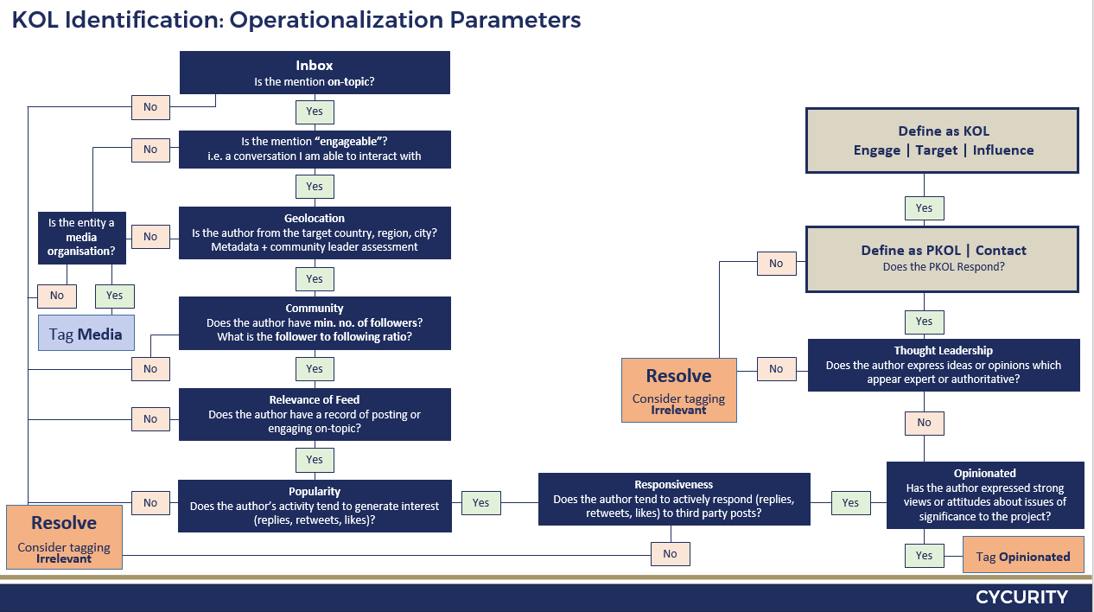**Key Opinion Leader Identification Procedure Using CX Social**

**Stage 6 –** Engaging with Influencers

How to Engage

* Evaluate tweet:
  + - Is the mention engageable?
    - Will the conversation be on-topic or off-topic?
* Evaluate KOL:
  + - Check for existing user tags
    - Compare name to handle
    - Check following – followers' ratio
    - Read bio
    - Check pictures/videos preview section
    - Check level of responsiveness [RTs vs. Replies]
* Choose channel
* Choose action
* Tag [user tag + mention tag]
* Resolve

CM Daily Routine

* Read emails
* Review Google Alerts – keep up to date on relevant current affairs and news.
* Manually review online media outlets – a great source for relevant content to broadcast ["publish a new message"] or for retweeting ["save a new message"].
* Login to CS-Social check smart folders in the following order:
  + Replies
  + RTs
  + KOLs
  + P-KOLs
  + Opinionated
  + Inbox

TAGGING

**User Tags**

Every mention that is processed by a CL includes tagging. Both the mention and the KOL need to be tagged with a mention tag and a user tag respectively.

Always tag the channel’s name (so we can know for the future with which channel to engage with the specific KOL).

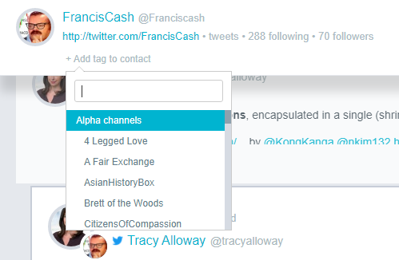

If the conversation is on-topic and the entity answers the project's criteria tag with P-KOL user tag.

If the conversation is off topic – consider tagging 'opinionated' or irrelevant (see below).

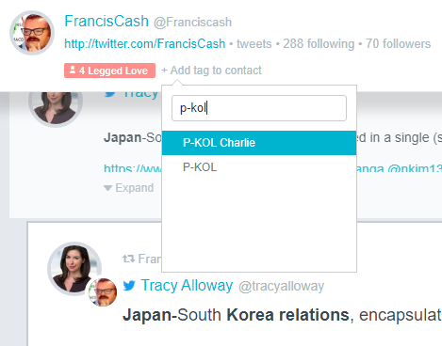

If the P-KOL engages with your channel, change the P-KOL tag to a KOL tag (by deleting the P-KOL tag)

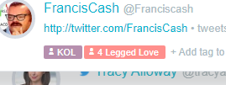

If the content of mention in your inbox is irrelevant for the project or the entity is not a human entity [Twitter bot, RSS feed, spam] tag the entity as "irrelevant."

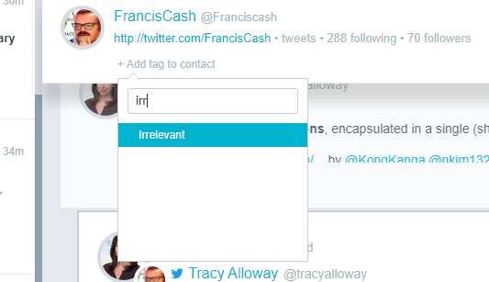

If a mention comes in to your inbox by a news outlet, organization, etc. tag it as opinionated. These will later be used for relevant content for RTs, broadcasting and likes.

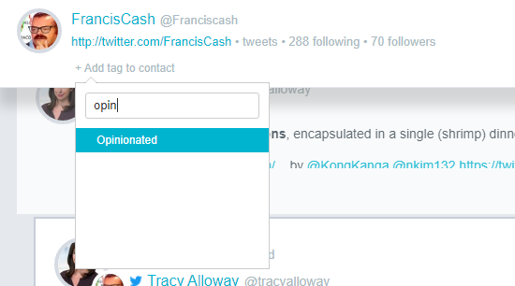

**Broadcasting Tags**

There are two types of broadcasts you can do:

* Targeted broadcast
* Off-topic broadcast

Off-topic broadcasts require no tagging.

Targeted broadcasting needs to be tagged as “broadcast”.

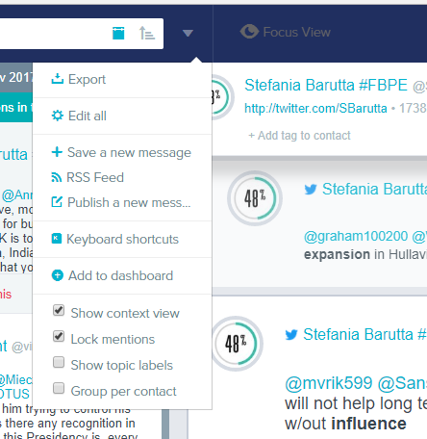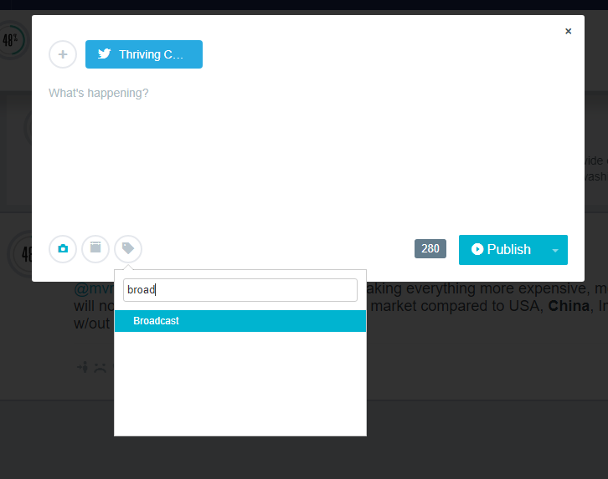

**Mention Tags**

These tags are only to be used on mentions. They are linear tags – meaning they have an order to them (contacted 🡪 engaged 🡪 targeted 🡪 influenced). This also means that if a conversation was tagged influenced at some point, it also must have been tagged all previous three tags (contacted, engaged and targeted).

Contacted

This tag will be used once per conversation with one KOL. Meaning, the first time you send a reply to a new P-KOL, that first message (and that message alone) should be tagged “contacted”. If during the conversation another KOL joins in and you engage with them as well, they will also be marked as contacted.

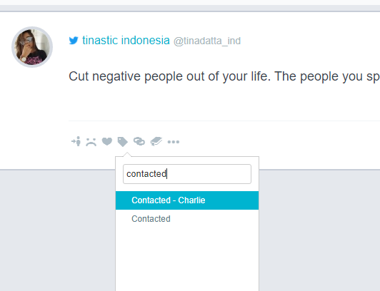

Will end up looking like this:

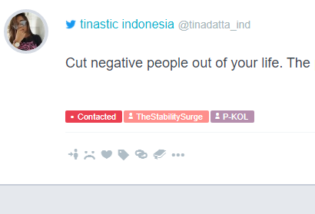

Engaged

This tag will be used once the P-KOL engages with you in any way (like, RT or reply) which also means they have turned into a KOL.

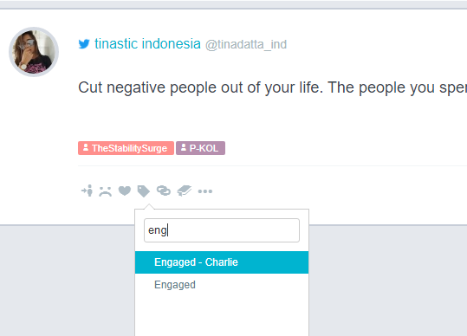

Will end up looking like this:

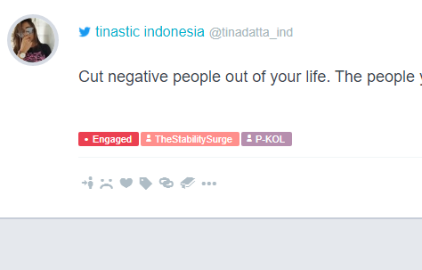

The “engaged” tag will be used **EVERY** time the KOL interacts with you. This can happen as many times as needed. The “engaged” tag can be used together with any other tag (engaged + targeted; engaged + influenced).

Targeted

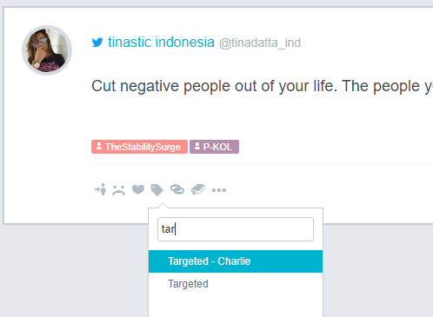This tag will be used once you send a “targeted” (on target message) reply to the KOL. Note: that this can also happen on the very first reply you send to a new P-KOL.

Will look like this:

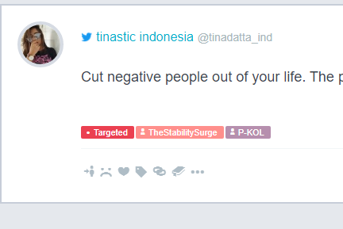

Or, for example:

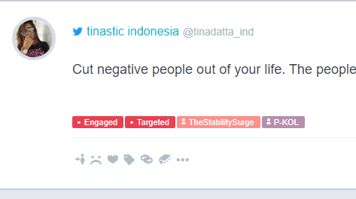

1. Influenced

This tag will be used once the KOL becomes “influenced”. This happens when they positively react to a “targeted” message by either liking, retweeting or replying.

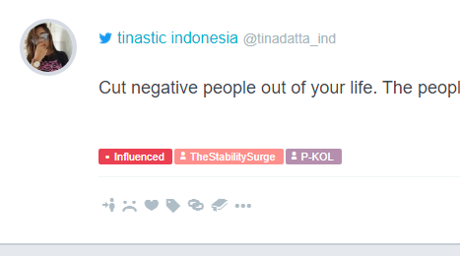

Note: an “influenced” tag can never appear without ALL the previous tags (contacted, engaged, influenced). If the first message you send a KOL is “targeted”, and the KOL likes that message – it will in fact be marked all 4 tags. “contacted” – because it’s the first time you send a message to them. “targeted” – because the message you sent is on “key message”. “engaged” – because they ‘interact’ with you (like). “influenced” – because they liked a ‘on key message’ reply.

**Following a KOL**

In order to improve our channels and grow their following, we always follow a KOL once they’ve interacted with us – i.e. if you sent a reply and got a response – follow the KOL (of course there are exceptions but this is the general rule).

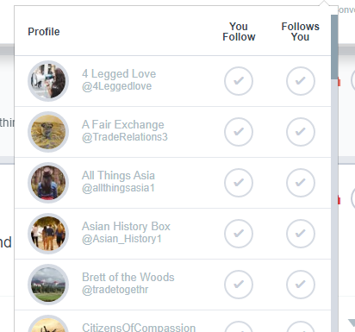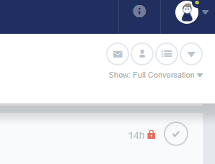



**Stage 7 –** Measure Influence on Discourse

Internal KPIs – Influencing Indicators

Conversion Rates

External KPIs

Reach

Discourse Analysis

Mentions

Correlation

Appendix

|  |  |  |
| --- | --- | --- |
| Stage | Resource | Duration |
| Project | Project Manager | 3 Months |
| Project Initiation |  |  |
| Project goal definition based on proposal |  |  |
| Preliminary research |  |  |
| * Project goal definition based on Operational tasks |  |  |
| * Project goal validation with product owner (Mark/ Aviram) |  |  |
| Planning |  |  |
| Project Strategy |  |  |
| Project Budget |  |  |
| Project Time constraints (deliverables) |  |  |
| Project Work packages |  |  |
| Project Risk mitigation plan |  |  |
| Project Personnel requirement (team) |  |  |
| Project Infrastructure requirement (channels) |  |  |
| * Project plan (red team) |  |  |
| Setup |  |  |
| Build Infrastructure |  |  |
| Team Recruitment |  |  |
| Team Training |  |  |
| Build Query |  |  |
| Structure Daily Report |  |  |
| Execution |  |  |
| Production line initiation |  |  |
| Closing |  |  |
| Transition of daily responsibility to team leader |  |  |

|  |  |  |
| --- | --- | --- |
| Stage | Resource | Duration |
| Production Line Operation |  |  |
| Daily Work Plan | TL |  |
| Daily brief | TL | 10 Mins |
| Daily topic analysis | CM | 40 Mins |
| Daily Engagement Process | CM+OP | 10 Min > per every Reply |
| Replies |  |  |
| KOL Folder |  |  |
| PKOL Folder |  |  |
| Inbox |  |  |
| Daily debrief | TL+CM+OP |  |
| Daily report | TL |  |
| Weekly Debrief |  |  |
| Weekly team meeting with PM | PM+TL+CM+OP |  |
| Weekly PM meeting with PMO | PM+PMO |  |
| Bi-Weekly Report to Customer | PM |  |
| Support |  |  |
| Infrastructure | COO |  |
| QA | PMO |  |
| QC | KC |  |
| Research Center | KC+PM |  |
| Creative | KC |  |
| QDA | KC |  |
| Analysis | KC |  |

1. Klout was deactivated in 2018.
2. For a full KOL definition and outline of the KOL identification process, refer to Stage 5 of the SDI project design: “Monitor and Identify Influencers”.
3. Details elsewhere.